# APDS7311 Document

## Circle-Ci Pipeline

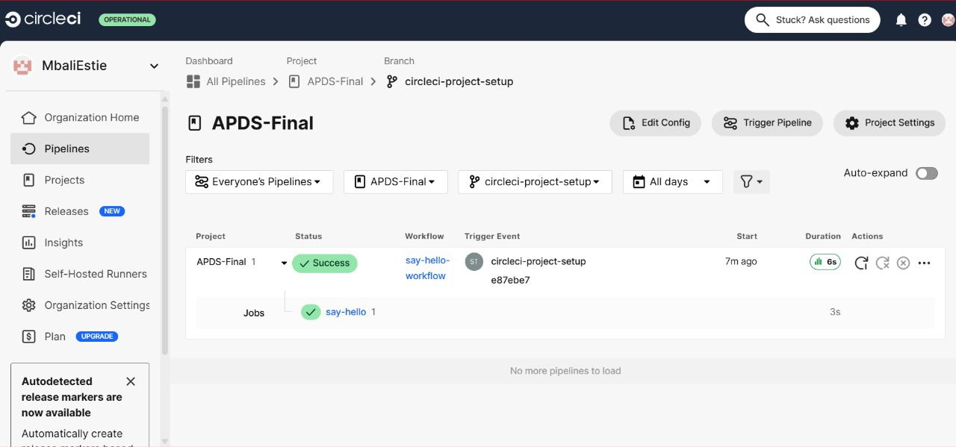

## SonarQube

SonarCloud

GitHub 1: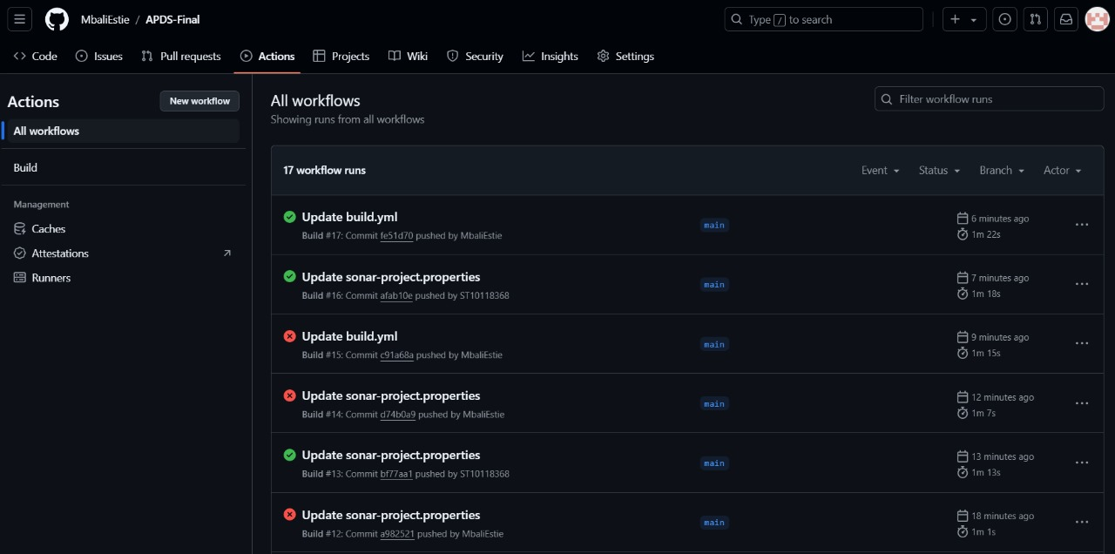

GitHub 2

